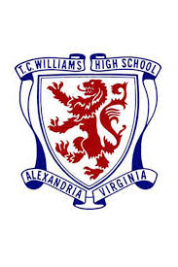
Reunion Weekend
TITANS
TC Williams Class of ’77

Friday OCT. 6
6:00 – 9:00 PM - Happy Hour - Joe Theismann’s Restaurant & Pub (next to Embassy Suites)
(Cash food & drinks on own) – Reserved TC’77 Area - Letter Jacket / TC Apparel Night
Address – 1800 Diagonal Rd Ste A, Alexandria, VA 22314 (walk from Embassy Suites or Hilton)
Saturday OCT. 7
12 Noon – 1 Hour Tour of TC Williams HS
Escorted group tour (free) – please meet at Door #14, 12 p.m. sharp – no late tours
Address – 3330 King St, Alexandria, VA 22302

Saturday OCT. 7
7:00 PM - TC’77 Welcome Reception – Ballroom Foyer (hosted food) –
Cash Bar
8:00 PM Open with Prayer (Dr. Tincie Lynch)
8:00 PM Ballroom (Gourmet buffet, Group Photo, DJ (Cash Bar)
8:30 – 9:00 Special Jazz Performance (Geneva Renee)
9:00 – 11:30 DJ

Address - Embassy Suites Old Town - 1900 Diagonal Road - Alexandria

Sunday - OCT 8
10:00 AM – 11:30 AM – Brunch - reserved area
(Full Buffet breakfast included w/hotel rate at Embassy Suites (non-guests welcome – order from a la carte menu/pay own on)
Embassy Suites Old Town - Lobby Restaurant - 1900 Diagonal Road – Alexandria
TC Apparel

